

**Polling District and Polling Place Review 2025**

**Gosforth Ward**

**Parliamentary Constituency:** North

**(Proposed) Polling Districts:** K01, K02, K03, K04, K05, K06, K07

The Local Government Boundary Commission for England are an independent body accountable to Parliament. They are responsible for reviewing councils to make sure their patterns of internal wards are fair and sensible. Their reviews include at least two rounds of public consultation before they make recommendations for change.

The final recommendations were published on 7 January 2025, and the new arrangements apply to local elections from 2026.

As a result of changes to ward boundaries the Acting Returning Officer (ARO) is conducting a review of polling districts and polling places to ensure that they are suitable for the new ward boundaries.

For more information on the local government boundary review visit: <https://www.lgbce.org.uk/all-reviews/newcastle-upon-tyne>

This document provides details of the review, along with the initial recommendations and comments of the Acting Returning Officer (ARO). Also, the election rules require the ARO to decide how many polling stations are required for each polling station and the ARO must allocate electors to the polling stations in such manner as they think most convenient.

These recommendations will be open to all residents, stakeholders, and any interested parties. We shall be seeking representations from local disability groups on the accessibility and suitability of polling places. Any comments should be addressed in the first instance to pollingplaces@newcastle.gov.uk where they will be collated on behalf of the (Acting) Returning Officer.

We considered the following factors:

* **Identifying new polling places:** We will look for new polling places in areas where the existing provision is unsuitable or unavailable.
* **Feedback:** We will consider feedback received following recent elections, consultation from members of the public, elected members, and other stakeholders.
* **Accessibility:** We will try to ensure that every polling place is accessible to electors with disabilities.
* **Facilities**: We will make sure that all electors have such reasonable facilities for voting as are practicable in the circumstances.
* **Elector numbers:** We will try to comply with the Electoral Commission guidance on the maximum number of electors that should be allocated to a polling station which should not exceed 2,250.
* **Future housing developments**: We will consider the impact of proposed housing developments on polling station electorates.

**(Current) Gosforth Ward**

This map shows the current ward and polling district boundaries and the polling places.

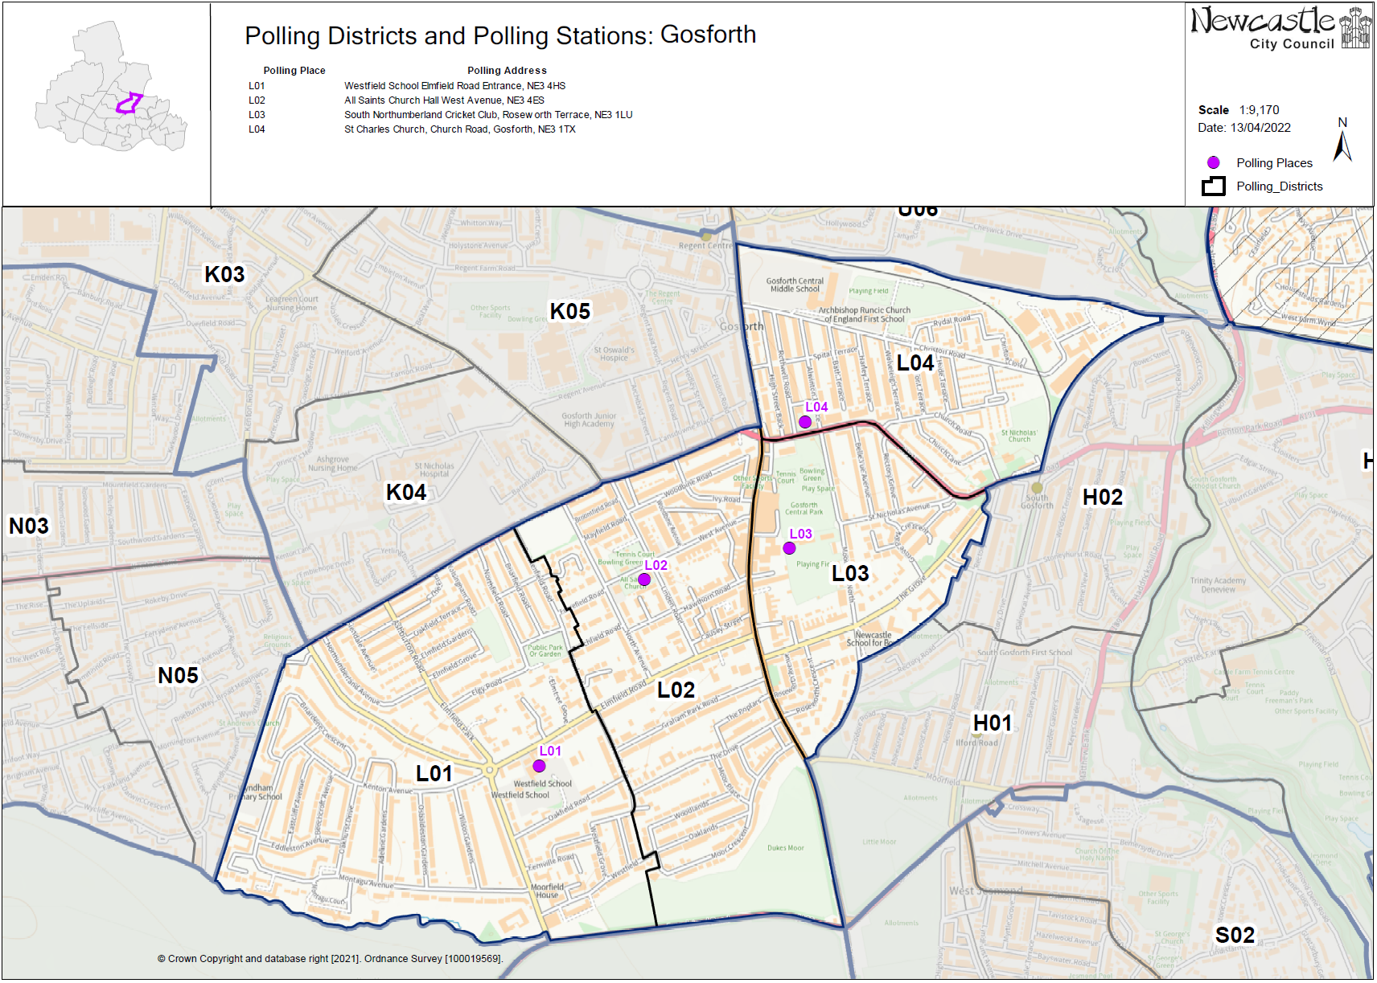

**(New)**

**Gosforth Ward**

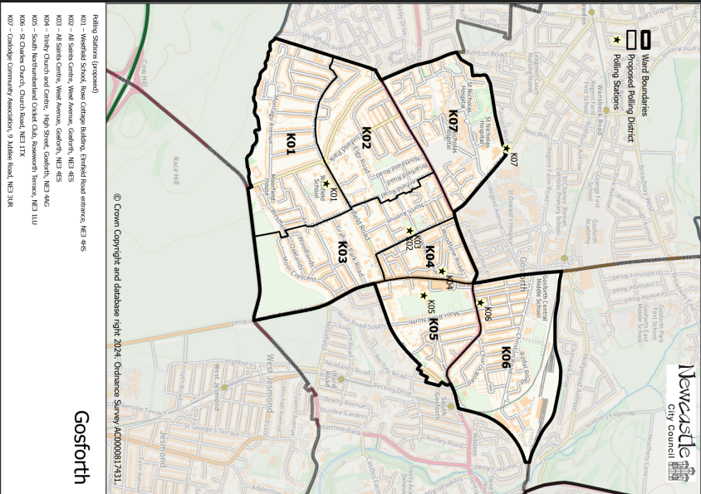This map shows the new ward and the proposed polling districts and the proposed polling places.

* **K01**

Westfield School, Rose Cottage Building, Elmfield Road entrance, NE3 4HS

* **K02**

All Saints Centre, West Avenue, Gosforth, NE3 4ES

* **K03**

All Saints Centre, West Avenue, Gosforth, NE3 4ES

* **K04**

Trinity Church and Centre, High Street, Gosforth, NE3 4AG

* **K05**

South Northumberland Cricket Club, Roseworth Terrace, NE3 1LU

* **K06**

St Charles Church, Church Road, NE3 1TX

* **K07**

Coxlodge Community Association, 9 Jubilee Road, NE3 3UR

**Gosforth Ward**

**Polling District K01**

|  |  |  |
| --- | --- | --- |
| **Current Polling District** | | **Current Polling Place** |
| L01 (part of) | | Westfield School, Rose Cottage Building, Elmfield Road Entrance, NE3 4HS |
|  | | |
| **Proposed Polling District** | **Predicted Polling Station Electorate** | **Proposed Polling Place** |
| K01 | 712 | Westfield School, Rose Cottage Building, Elmfield Road Entrance, NE3 4HS |
|  | | |
| **Considerations and Proposals** | | |
| Part of current L01 would become the proposed K01 district. Properties south of Kenton Avenue would form the proposed K01 district.  No change to the polling place. | | |
|  | | |
| **Preliminary Consultation – Elected Members comments and feedback** | | |
| No comments received. | | |

**Gosforth Ward**

**Polling District K02**

|  |  |  |
| --- | --- | --- |
| **Current Polling District** | | **Current Polling Place** |
| L01 (part of) | | Westfield School, Rose Cottage Building, Elmfield Road entrance, NE3 4HS |
|  | | |
| **Proposed Polling District** | **Predicted Polling Station Electorate** | **Proposed Polling Place** |
| K02 | 862 | All Saints Centre, West Avenue, Gosforth, NE3 4ES |
|  | | |
| **Considerations and Proposals** | | |
| Part of current L01 would become the proposed K02 district. Properties north of Kenton Avenue would form the proposed K02 district.  Westfield School was considered as a double polling station however space is an issue. The proposal is to use All Saints Centre as a double station for proposed districts K02 and K03. | | |
|  | | |
| **Preliminary Consultation – Elected Members comments and feedback** | | |
| No comments received. | | |

**Gosforth Ward**

**Polling District K03**

|  |  |  |
| --- | --- | --- |
| **Current Polling District** | | **Current Polling Place** |
| L02 (part of) | | All Saints Centre, West Avenue, Gosforth, NE3 4ES |
|  | | |
| **Proposed Polling District** | **Predicted Polling Station Electorate** | **Proposed Polling Place** |
| K03 | 707 | All Saints Centre, West Avenue, Gosforth, NE3 4ES |
|  | | |
| **Considerations and Proposals** | | |
| Part of the current L02 would become the proposed K03 district. Properties to the west of Linden Road and from the south of Salters Road would form the proposed K03 district.  No change to the polling place. The proposal is to use All Saints Centre as a double station for proposed districts K02 and K03. | | |
|  | | |
| **Preliminary Consultation – Elected Members comments and feedback** | | |
| No comments received. | | |

**Gosforth Ward**

**Polling District K04**

|  |  |  |
| --- | --- | --- |
| **Current Polling District** | | **Current Polling Place** |
| L02 (part of) | | All Saints Centre, West Avenue, Gosforth, NE3 4ES |
|  | | |
| **Proposed Polling District** | **Predicted Polling Station Electorate** | **Proposed Polling Place** |
| K04 | 512 | Trinity Church and Centre, High Street, Gosforth, NE3 4AG |
|  | | |
| **Considerations and Proposals** | | |
| Part of the current L02 would become the proposed K04 district. Properties to the east of Linden Road and north of Elmfield Road would form the proposed K04 district.  Trinity Church and Centre is the new proposal, as the location is better suited to the electorate. A site visit was conducted on 7 August 2025 and the building met accessibility requirements to be used as a polling station. | | |
|  | | |
| **Preliminary Consultation – Elected Members comments and feedback** | | |
| No comments received. | | |

**Gosforth Ward**

**Polling District K05**

|  |  |  |
| --- | --- | --- |
| **Current Polling District** | | **Current Polling Place** |
| L03 (part of) | | South Northumberland Cricket Club, Roseworth Terrace, NE3 1LU |
|  | | |
| **Proposed Polling District** | **Predicted Polling Station Electorate** | **Proposed Polling Place** |
| K05 | 384 | South Northumberland Cricket Club, Roseworth Terrace, NE3 1LU |
|  | | |
| **Considerations and Proposals** | | |
| Part of the current L03 would be the proposed K05. Loses some properties south of The Grove to Dene and South Gosforth ward.  No change to the polling place. | | |
|  | | |
| **Preliminary Consultation – Elected Members comments and feedback** | | |
| No comments received. | | |

**Gosforth Ward**

**Polling District K06**

|  |  |  |
| --- | --- | --- |
| **Current Polling District** | | **Current Polling Place** |
| L04 (full)  U06 (part of) | | St Charles Church, Church Road, NE3 1TX  Garden Village Hall, Rosewood Avenue, NE3 5DD |
|  | | |
| **Proposed Polling District** | **Predicted Polling Station Electorate** | **Proposed Polling Place** |
| K06 | 1021 | St Charles Church, Church Road, NE3 1TX |
|  | | |
| **Considerations and Proposals** | | |
| Current L04 and a small part of current U06, would merge to form the proposed K06 district.  Gosforth Central Middle School was considered however it was deemed that this building would not be a viable option to use as a polling station.  No change to the polling place. | | |
|  | | |
| **Preliminary Consultation – Elected Members comments and feedback** | | |
| No comments received. | | |

**Gosforth Ward**

**Polling District K07**

|  |  |  |
| --- | --- | --- |
| **Current Polling District** | | **Current Polling Place** |
| K04 (part of) | | Coxlodge Community Association, 9 Jubilee Road, NE3 3UR |
|  | | |
| **Proposed Polling District** | **Predicted Polling Station Electorate** | **Proposed Polling Place** |
| K07 | 385 | Coxlodge Community Association, 9 Jubilee Road, NE3 3UR |
|  | | |
| **Considerations and Proposals** | | |
| Most of the current K04 district would become the proposed K07 district. Loses a very small part of the district to Fawdon and West Gosforth ward.  No change to the polling place. | | |
|  | | |
| **Preliminary Consultation – Elected Members comments and feedback** | | |
| No comments received. | | |

THIS PAGE IS INTENTIONALLY BLANK